NAME – Kunal Rajendra Barde
NYU ID- N11769520
Sub – CN

Socket Programming Assignment 3 : SMTP

Source Code :

from socket import *
import ssl
import base64
msg ="\r\n I love computer networks!"
endmsg="\r\n.\r\n"

mailserver='smtp.gmail.com'
port=587

clientSocket=socket(AF_INET, SOCK_STREAM)
clientSocket.connect((mailserver,port))
recv=clientSocket.recv(1024)
print recv
if recv[:3] !='220':
print '220 reply not received from server.'

helloCommand='HELO smtp.gmail.com\n'
clientSocket.send(helloCommand)
recv1=clientSocket.recv(1024)
print recv1
if recv1[:3]!='250':
print '250 reply not received from server.'

command="STARTTLS\r\n"
clientSocket.send(command)
print clientSocket.recv(1024)

ssl_clientSocket = ssl.wrap_socket(clientSocket)
ehlo = 'EHLO [192.168.0.11]\r\n'
ssl_clientSocket.send(ehlo)
recv2 = ssl_clientSocket.recv(1024)
print recv2
if recv2[:3] != '250':
print '250 reply not received from server.'

ssl_clientSocket.send('Auth Login\r\n')
ssl_clientSocket.send(base64.b64encode('kunal2991@gmail.com')+'\r\n')
ssl_clientSocket.send(base64.b64encode('Arjun1997')+'\r\n')

recv3 = ssl_clientSocket.recv(1024)
print recv3

sender="MAIL FROM: <kunal2991@gmail.com>\r\n"
ssl_clientSocket.send(sender)
recv4 = ssl_clientSocket.recv(1024)
print recv4

receipient="RCPT TO: <krb385@nyu.edu>\r\n"
ssl_clientSocket.send(receipient)
recv5 = ssl_clientSocket.recv(1024)
print recv5

SUBJECT = "DATA\r\n"
ssl_clientSocket.send(SUBJECT)
recv6 = ssl_clientSocket.recv(1024)
print recv6

text="Welcome, you have successfully completed the SMTP Assignment\r\n.\r\n"
ssl_clientSocket.send(text)
recv7 = ssl_clientSocket.recv(1024)
print recv7

quit_="QUIT"
ssl_clientSocket.send(quit_)
recv8 = ssl_clientSocket.recv(1024)
print recv8

Output :

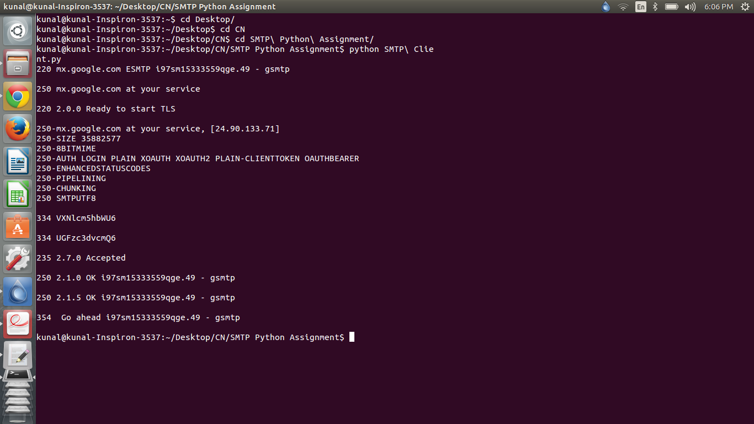

Screenshot of Terminal Execution

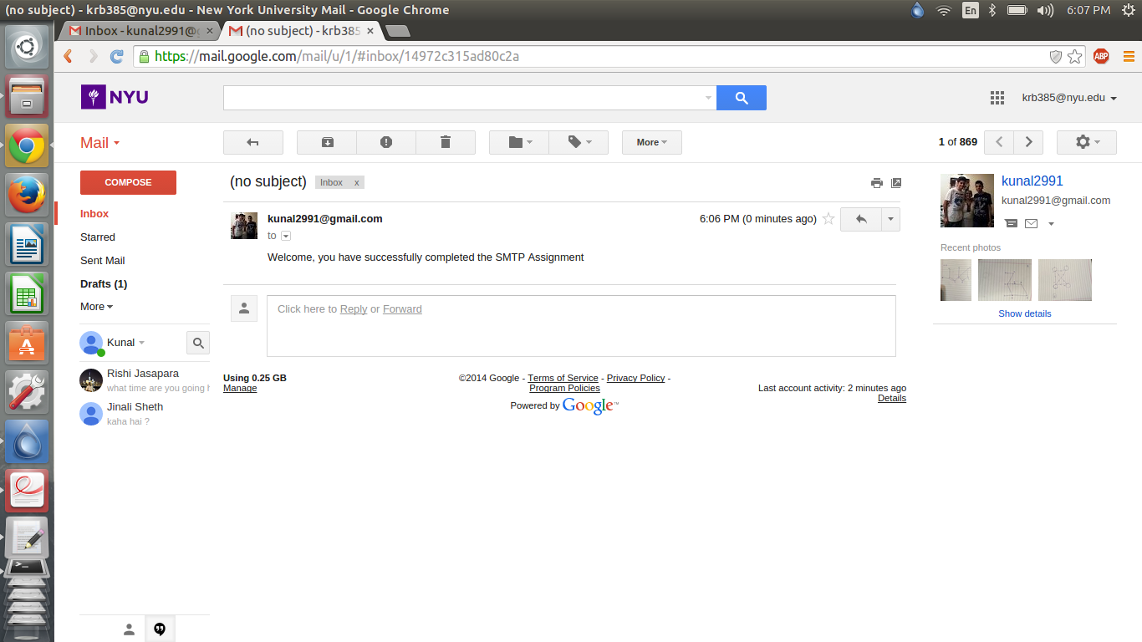
Screenshot of Email received

